📄 NYC Restaurant Inspection Analysis – Business Problem Document

1. Project Overview
New York City conducts thousands of restaurant health inspections each year to ensure food safety and public health. These inspections generate large volumes of data, including inspection scores, grades, violations, business information, and locations.
However, this data is difficult for non-technical stakeholders to interpret.
This project converts raw NYC restaurant inspection data into actionable business insights using Python, SQL, and Power BI.

2. Problem Statement
Analyze NYC restaurant inspection records to:
- Identify trends in violations and inspection grade outcomes
- Compare hygiene performance across boroughs and cuisines
- Determine the key factors responsible for poor inspection results
The goal is to help:
- Restaurant owners improve hygiene compliance
- City officials target inspections effectively
- Consumers make safer dining choices

3. Business Objectives
The main objectives of this project are:
- Identify boroughs with poor and good hygiene performance.
- Identify high-risk cuisine categories.
- Discover common violations that lead to bad inspection grades.
- Identify restaurants that repeatedly perform poorly.
- Analyze time and seasonal trends in inspection severity.

4. Data & Tools
- Dataset: NYC Restaurant Inspection Data
- Tools Used:
  - Python – Data Cleaning
  - SQL – Data Analysis
  - Power BI – Visualization

5. Analytical Approach

Step 1: Data Cleaning (Python)
- Removed invalid borough values like '0'
- Standardized grade values (A, B, C)
- Converted grades into numeric scale (A = 1, B = 2, C = 3)
- Processed date formats for time series analysis

Step 2: SQL Data Analysis
Below are the key SQL queries used along with their purpose.

5.1 Borough Hygiene Performance
Query:
SELECT
boro,
AVG(score) AS avg_score
FROM inspection
WHERE score IS NOT NULL AND boro <> '0'
GROUP BY boro
ORDER BY avg_score DESC;

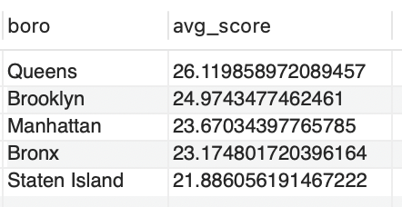
Insight:
- Queens recorded the worst average inspection score (26.11)
- Staten Island recorded the best average score (21.88)
This indicates that restaurants in Queens need greater inspection focus.

5.2 Cuisine Performance
Query:
SELECT cuisine_description,
AVG(CASE grade
WHEN 'A' THEN 1
WHEN 'B' THEN 2
WHEN 'C' THEN 3
END) AS avg_grade_score
FROM inspection
WHERE grade IN ('A','B','C')
GROUP BY cuisine_description
ORDER BY avg_grade_score DESC;

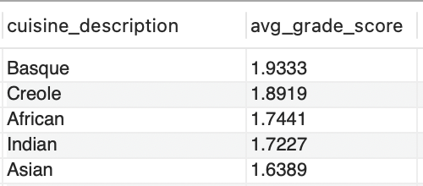
Insight:
High-risk cuisines based on average grade scores:
- Basque – 1.93
- Creole – 1.89
- African – 1.74
- Indian – 1.72
- Asian – 1.63
These cuisines were more likely to receive lower grades.

5.3 Violation Codes Linked to Bad Grades
Query:
SELECT violation_code, violation_description,
COUNT(*) AS bad_grade_count
FROM inspection
WHERE grade IN ('B','C')
GROUP BY violation_code, violation_description
ORDER BY bad_grade_count DESC
LIMIT 10;

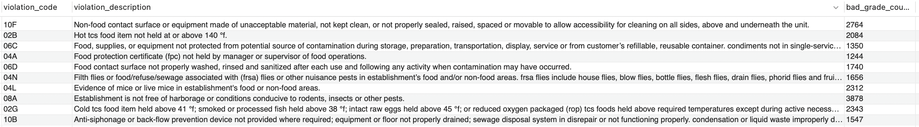
Insight:
Violations most associated with poor grades:
- 08A – Rodent / pest infestation
- 04L – Evidence of mice
- 02G – Unsafe cold food storage
- 02B – Unsafe hot food storage
- 06D – Unsanitary food contact surfaces
These are the biggest contributors to poor hygiene ratings.

5.4 Repeat Offender Restaurants
Query:
SELECT camis, dba, COUNT(*) AS bad_inspections
FROM inspection
WHERE grade IN ('B','C')
GROUP BY camis, dba
HAVING bad_inspections >= 3
ORDER BY bad_inspections DESC
LIMIT 10;

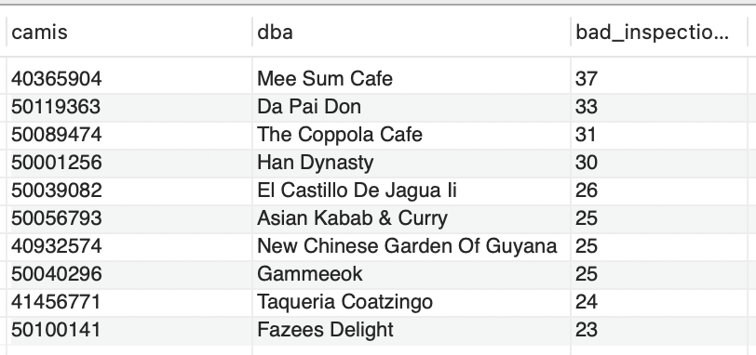
Insight:
Worst performing restaurants based on bad inspection history:
- Mee Sum Cafe – 37 bad inspections
- Da Pai Don – 33 bad inspections
- The Coppola Cafe – 31 bad inspections
- Han Dynasty – 30 bad inspections
These restaurants show persistent hygiene issues.

5.5 Inspection Time Trend
Query:
SELECT
YEAR(inspection_date) AS year,
MONTH(inspection_date) AS month,
COUNT(*) AS total_inspections,
AVG(score) AS avg_score
FROM inspection
GROUP BY YEAR(inspection_date), MONTH(inspection_date)
ORDER BY total_inspections DESC;

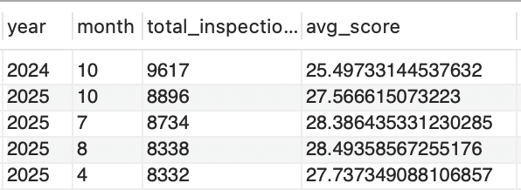
Insight:
- October has the highest inspection volume each year.
- Worst average inspection scores occurred during mid-2025 (July–August).
This suggests seasonal operational challenges for restaurants.

6. Key Business Insights Summary
- Queens has the worst hygiene performance among NYC boroughs, while Staten Island performs best.
- Basque and Creole cuisines are the highest risk categories based on inspection grades.
- Rodent infestation and improper food storage are major drivers of poor inspection outcomes.
- Several restaurants are repeat offenders, requiring focused regulatory action.
- Inspection severity increases during summer months, especially mid-2025.

7. Business Impact
These insights help:
- Restaurant owners identify critical hygiene problems.
- City authorities optimize inspection schedules and resources.
- Consumers make informed decisions about where to dine.

8. Future Improvements
- Add machine learning to predict inspection outcomes.
- Integrate real-time updates from NYC Open Data.
- Build risk category models for restaurants.
- Add neighborhood heat maps for high-risk zones.

9. Conclusion
This project demonstrates how government open data can be used for real-world policy insights using data analytics and business intelligence tools. It bridges technical analysis with practical decision-making needs.

